[EN-023] Template for the Proceedings of ENRI’s International Workshop on ATM/CNS 2013
Please add the Acceptance ID#

⁺M. Hajashi*, P. LeGrand**, B. Zoseki*
*ATM Department
Electronic Navigation Research Institute (ENRI)
For presenting author, please add “+” in front of the name.
Tokyo, Japan
[m-san | b-san]@enri.go.jp

**Department of Engineering and Control
Université Libre de Bruxelles
Bruxelles, Belgium
plg@university.be

Abstract This template describes the style and format of articles submitted to ENRI’s International ATM/CNS Workshop (EIWAC). Please follow these guidelines to guarantee homogeneous proceedings. Please write your own abstract containing 150-200 words.
Keywords keyword1, keyword2, …

INTRODUCTION
Table 1 Margins and Column Width
Position | Margin
Left margin | 20mm
Right margin | 20mm
Top margin | 25mm
Bottom margin | 25mm
Column width | 80mm

This template is to be used for the proceedings of ENRI’s International workshop on ATM/CNS (EIWAC 2013). This version (EIWAC2013.doc) is compatible with MS Word 2000-2007. This document is written in prescribed format. Please use this format for your own article to guarantee the homogeneity of the proceedings.

PAGE SIZE AND FORMAT

The format of the paper is A4 (21.0cm x 29.7cm). The paper has 2 columns. The margins are 20mm left and right and 25 mm top and bottom. The column size is 80mm (see Table 1). General font is Times new Roman. In the text its size is 10 pixels, inside tables and figure and table captions it is 8 pixels. The total length of a paper should not exceed 10 pages.

HIERARCHICAL STRUCTURE

Please use the sections, subsections and sub-subsections styles as a hierarchical structure in you document as shown below.

3.1 Subsection

Sub-subsection 1

Sub-subsection 2

FIGURES, TABLES AND EQUATIONS

Figures and Tables
Please place figures and tables at the top and bottom of columns.. Large figures and tables may span across both columns. Figure captions should be below the figures; table heads should appear above the tables. Use the abbreviation “Fig. 1”, even at the beginning of a sentence.

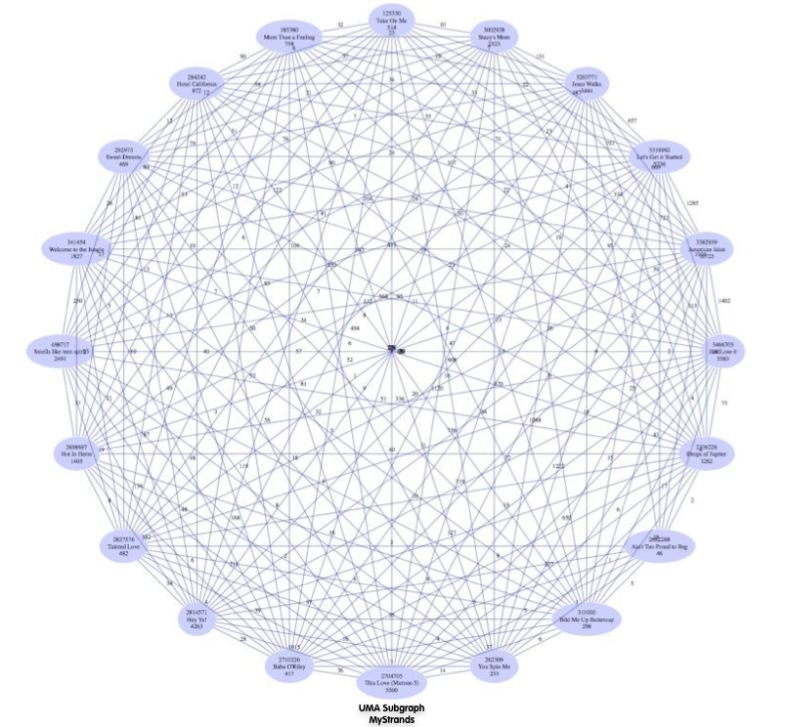
Figure 1 Example Figure

Equations
Equations should be numbered in Arabic numbers on the right hand margin, as in (1).
$P(\text{N=k})=\frac{e^{−\text{λn}}(\text{λn})^{k}}{\text{k!}}$, (1)
where $λ$ is the probability that an author submits his (her) paper without style errors and n the number of submissions.

ACKNOWLEDGMENTS

This template uses the styles of an ACM (Association for Computing Machinery) template and was created by the Electronic Navigation Research Institute, Japan (ENRI). It can be freely modified and redistributed.

REFERENCES
- Edmonds, J., Karp, R.M, “Theoretical improvements in algorithmic efficiency for network flow problems,” Journal of the Association for Computing Machinery, J. Assoc. Comput. Mach. (USA), vol.19, (no.2), April 1972. p.248-64.
- D. R. Cox, “The statistical analysis of congestion”. J. R. Statist. Soc. A 118 (1955), 324.

7. COPYRIGHT

Please add the following copyright statement in your paper:
“Copyright Statement
The authors confirm that they, and/or their company or institution, hold copyright of all original material included in their paper. They also confirm they have obtained permission, from the copyright holder of any third party material included in their paper, to publish it as part of their paper. The authors grant full permission for the publication and distribution of their paper as part of the EIWAC2013 proceedings or as individual off-prints from the proceedings.”

Please take care that columns on Last Page are as close as possible to equal length
Please note if you can accept this statement.

